**About The Dataset**

The Dataset is created using the macro economics values that effect the housing prices. The main factors that effect the housing market are as follows:

* Demand
* Financial Parameters
* Raw material Cost
* Government Polices

Explaining each component in details

**Demand**

The demand for the housing prices is directly proportional to the cost of housing. The demand and supply are the most important component is deriving and things values as the demand increase and the supply decreases the cost of the product increases.

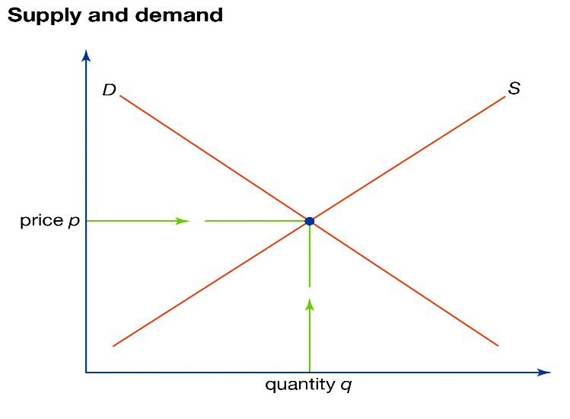

Now the demand increases with increase in population so the population is added as a parameter as in the dataset for the supply of the variable the number of housing units can be added as a parameter.

**Financial Parameters**

There are a number of financial parameters that effect the housing markets for market index , interest rate , gold prices and etc. The Nasdaq 100 index price is used for predictions , the gold prices are used for the for the predictions and the US interest rate is also used in the dataset . As the interest rate effect how the people take loans because owing house is mostly carried out through taking loans and interest rates are an important parameter for the so.

**Raw material Cost**

It is an important component as the material cost effect the costing of the housing units the raw material may include cement , steel ,fuel prices etc. So this component prices are added in the dataset for prediction .

**Government Policies**

The government policies are one of the important component is driving the housing prices as if the cost of various government taxes applied on the cost of housing can effect the cost of the house directly. And various other polices that are carried out for better housing can increase the interest of the people towards housing.

**Variables in the Dataset**

**Dependent Variable:**

* U.S. National Home Price

Independent Variable:

* Nasdaq 100 Index
* Energy price
* Interest Rates
* Gross Domestic Income
* Gross Domestic Product
* Population